ASSIGNMENT – 7 [11-12-2023]

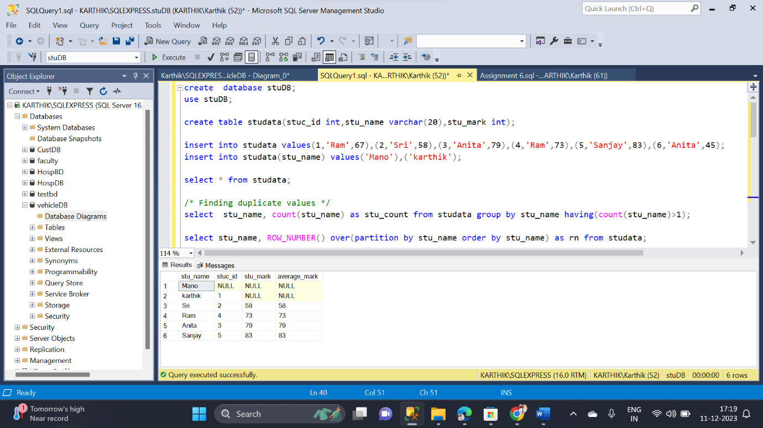By Karthikeyan K R

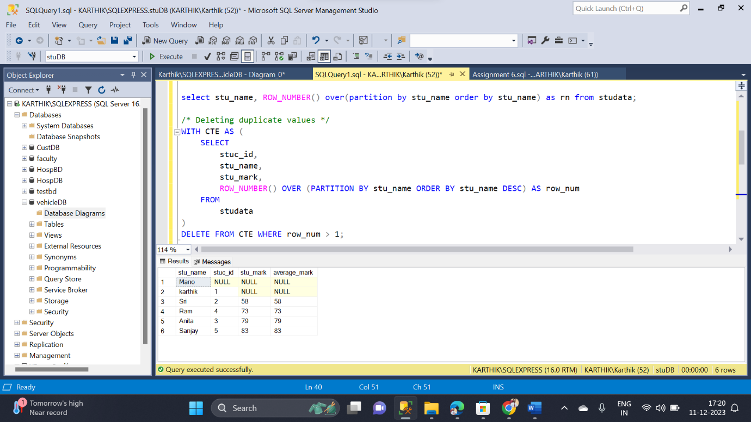

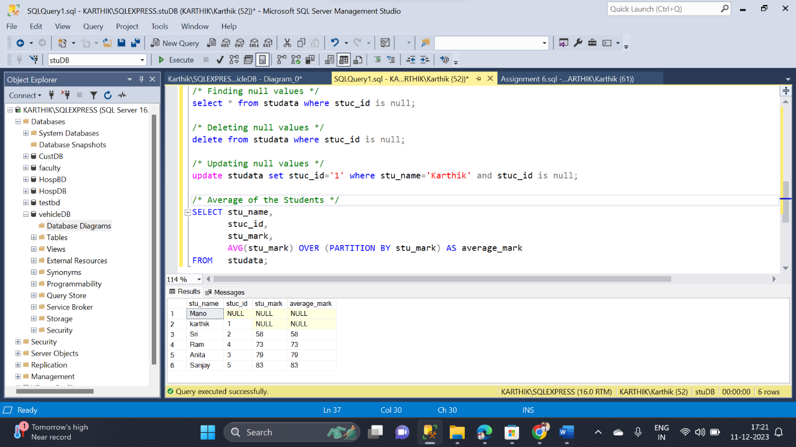

* In this assignment performed Data cleaning and Data Manipulation
* Duplicated values in the table are fined by using partition clause
* CTE clause are executed along with the partition clause
* Once the duplicate values are fined, then it is deleted by using delete command along with partition clause
* Then treatment for null values is carried out
* Finally simple partition function of average of marks is executed